C:\Documents and Settings\VIVEK BHARGAVA\Desktop\GBO letterheads.eps

SHRI RAM COLLEGE OF COMMERCE

GLOBAL BUSINESS OPERATIONS

University of Delhi, Maurice Nagar, Delhi – 110007

Phone: 27667905, 27666519 ▪ Fax: 27666510

Website: www.srcc.edu ▪ email: pgdgbo@srcc.du.ac.in

13th May, 2021

**NOTICE**

This is to inform you all that the last date for the submission of 4th Semester GBO Examination form is 17th May, 2021 (Monday), 5:00 p.m. No form will be accepted after this date.

Thanks

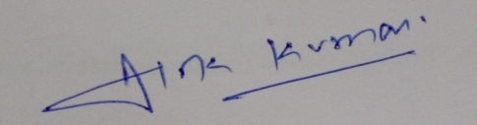

**(Dr. Alok Kumar)**

**Deputy Superintendent**